**Project description**

Each group has 4 deliverables: (**Phase2:** 50 grades)

* Total grades for the project should be **20 grades**. So, the grades will be scaled.
* The templates for your deliverables and your cover page are provided.
* Your deliverables will be submitted on **https://forms.gle/5tsks6cZURf1cwNUA**.
* This form is used to submit your different deliverables in course IS332 in the academic year (2022-2023)
* Please submit your file named T<Team number>-D<Deliverable number>.docx or .pdf. Example: T7-D2.docx
  + Do not add spaces in the filename.
  + Avoid zipping the file unless it is larger than 10 MB.
* Deliverable 2 **Firm Deadline is 26-11-2022**.

**Note that**

* Only one team member (**team leader**) can submit the project.
* Don’t submit multiple times.
* Cheating policy: Any copies will be graded zero.
* Clearly state your assumptions (only required ones).
* No handwritten reports and/or models are accepted [graded zero].
* You need to use any UML tool to depict your models and please mention the used tool(s) in your report.

[**Hint**: Review Chapters 4 - 5: domain class diagram & CRUD]

[**Tip**: Split the work among team members to help with time management]

**Project Details**

|  |  |
| --- | --- |
| Project number | *Project 1* |
| Project title | *Mega Store* |
| Corresponding TA\LA | *1* |
| Deliverable | *Phase 2* |

**Team Details**

|  |  |  |
| --- | --- | --- |
| **Student ID** | **Student name** | **Lab Group** |
| 20200403 | Loay Mohamed Hussien | S3-S4 |
| 20200490 | Mahmoud Ahmed Abdo | S1-S2 |
| 20200687 | Ibrahim Rashid Ibrahim | S1-S2 |
| 20200479 | Mohammed Nasser Abdel-Samea | S1-S2 |
| 20200125 | Ganna Allah Khaled Fouad | S3-S4 |
| 20201185 | Nadeen Medhat Assem Abdel-Latif | S3-S4 |
| 20200143 | Habiba Adel Lotfy ELbatrawy | S3-S4 |

# **Guidelines for Deliverable 2**

1. Apply the CRUD technique
2. Domain Class Diagram [Complete system]

* Domain Class Diagram based on the Noun technique.
* You need to follow the steps of the NOUN technique to identify the domain classes and document information using Tabular representations whenever possible. Please REFER to CHAPTER 4 in the book.
* You need to make use -as much as you can- of complex association types, i.e., generalization, aggregation, and composition.
* Your class diagram should also include multiplicities.
* Please specify the name of the associations in your model to increase readability.

1. State machine diagram (single object is enough). Please justify your selection.
2. Activity diagram(s) (at least 3 use cases)
3. System Sequence diagram(s) (for the same use cases in activity diagrams)

Please **clearly state** the name of the use case related to each model in steps 4 and 5.

1. **CRUD technique:**

Verify use cases using CRUD technique (e.g. Fig 5-12)

|  |  |  |
| --- | --- | --- |
| Domain Class | CRUD | Verified Use case |
| Manager | Create | Add Products  Provide services  Make offers  Provide different categories  Provide special bags  Has warehouses  Deal with suppliers  Make a financial report |
|  | Read/ Report | Add products information  Enhance services  Make a financial report  Operate different stores |
|  | Update | Add Products  Provide different categories  Deal with suppliers  Add products information  Enhance services  Operate different stores |
|  | Delete | Remove products  Make offers  Provide special bags  Has warehouses  Deal with suppliers  Make a financial report |

|  |  |  |
| --- | --- | --- |
| Domain Class | CRUD | Verified Use case |
| Customer | Create | Buy special bags  Buy products  Search for products |
|  | Read/ Report | Gain points  Achieved through website  Achieved through mobile app  Search for products  Add products to cart  Checkout |
|  | Update | Return products  Visit physical location  Add products to cart  Checkout |
|  | Delete | Add products to cart |

|  |  |  |
| --- | --- | --- |
| Domain Class | CRUD | Verified Use case |
| Product | Create | Deal with suppliers |
|  | Read/Report | Add Products  Remove products  Add products information  Add products to cart  Return products  Buy products  Search for products |
|  | Update | Add products information  Add products to cart  Return products  Buy products |
|  | Delete |  |

|  |  |  |
| --- | --- | --- |
| Domain Class | CRUD | Verified Use case |
| Offers | Create | Make offers |
|  | Read/Report | Make offers  Gain points  Checkout |
|  | Update | Checkout |
|  | Delete | Make offers |

|  |  |  |
| --- | --- | --- |
| Domain Class | CRUD | Verified Use case |
| Supplier | Create | Deal with suppliers |
|  | Read/Report | Deal with suppliers |
|  | Update | Deal with suppliers |
|  | Delete | Deal with suppliers |

|  |  |  |
| --- | --- | --- |
| Domain Class | CRUD | Verified Use case |
| Category | Create | Provide different categories |
|  | Read/Report | Provide different categories |
|  | Update | Provide different categories |
|  | Delete |  |

|  |  |  |
| --- | --- | --- |
| Domain Class | CRUD | Verified Use case |
| specialBags | Create | Provide special bags |
|  | Read/Report | Provide special bags  Gain points  Buy special bags |
|  | Update | Gain points  Buy special bags |
|  | Delete | Provide special bags |

|  |  |  |
| --- | --- | --- |
| Domain Class | CRUD | Verified Use case |
| History | Create | Enhance services |
|  | Read/Report | Enhance services |
|  | Update |  |
|  | Delete |  |

|  |  |  |
| --- | --- | --- |
| Domain Class | CRUD | Verified Use case |
| Report | Create | Make a financial report |
|  | Read/Report | Make a financial report |
|  | Update |  |
|  | Delete | Make a financial report |

|  |  |  |
| --- | --- | --- |
| Domain Class | CRUD | Verified Use case |
| Store | Create | Operate different stores |
|  | Read/Report | Operate different stores  Buy products  Achieved through website  Achieved through mobile app |
|  | Update | Operate different stores  Buy products |
|  | Delete |  |

|  |  |  |
| --- | --- | --- |
| Domain Class | CRUD | Verified Use case |
| Payment | Create | Return products  Buy products  Checkout |
|  | Read/Report | Return products  Gain points  Buy special bags  Buy products  Checkout |
|  | Update | Gain points  Buy special bags  Buy products  Checkout |
|  | Delete | Checkout |

CRUD table showing use cases and corresponding domain classes (e.g. Fig 5-13)

|  |  |  |  |  |  |  |  |  |  |  |  |
| --- | --- | --- | --- | --- | --- | --- | --- | --- | --- | --- | --- |
| Use case vs Domain Class | Manager | Customer | Product | Offers | Supplier | Category | SpecialBags | History | Report | Store | Payment |
| Add Products | C U | - | R | - | - | - | - | - | - | - | - |
| Add products information | R U | - | R U | - | - | - | - | - | - | - | - |
| Provide services | C | - | - | - | - | - | - | - | - | - | - |
| Make offers | C D | - | - | C R D | - | - | - | - | - | - | - |
| Remove products | D | - | R | - | - | - | - | - | - | - | - |
| Has warehouses | C D | - | - | - | - | - | - | - | - | - | - |
| Deal with suppliers | C U D | - | C | - | C R U D | - | - | - | - | - | - |
| Provide different categories | C U | - | - | - | - | C R U | - | - | - | - | - |
| Provide special bags | C D | - | - | - | - | - | C R D | - | - | - | - |
| Enhance services | R U | - | - | - | - | - | - | C R | - | - | - |
| Make a financial report | C R D | - | - | - | - | - | - | - | - | - | - |
| Operate different stores | R U | - | - | - | - | - | - | - | - | C R U | - |
| Add products to cart | - | R U D | R U | - | - | - | - | - | - | - | - |
| Return products | - | U | R U | - | - | - | - | - | - | - | C R |
| Gain points | - | R | - | R | - | - | R U | - | - | - | R U |
| Buy special bags | - | C | - | - | - | - | R U | - | - | - | R U |
| Buy products | - | C | R U | - | - | - | - | - | - | R U | C R U |
| Visit physical location | - | U | - | - | - | - | - | - | - | - | - |
| Achieved through website | - | R | - | - | - | - | - | - | - | R | - |
| Achieved through mobile app | - | R | - | - | - | - | - | - | - | R | - |
| Search for products | - | C R | R | - | - | - | - | - | - | - | - |
| Checkout | - | R U | - | R U | - | - | - | - | - |  | C R U D |

Applying noun technique:

|  |  |
| --- | --- |
| corporation | Included |
| mega store | excluded |
| Retail | excluded |
| Wholesaling | excluded |
| Chain of hypermarkets | excluded |
| Groceries stores | excluded |
| Convenience stores | excluded |
| Countries | excluded |
| Different types of stores | Included |
| Smaller supermarkets | excluded |
| Stores | Included |
| Size | excluded |
| Population | excluded |
| Categories | Included |
| Fruits | excluded |
| Vegetables | excluded |
| Dairy products | excluded |
| Meat | excluded |
| Grocery | excluded |
| Beverages | excluded |
| Tv and appliances | excluded |
| Laundry and detergents | excluded |
| Cleaning essentials | excluded |
| Personal and baby care | excluded |
| Frozen food | excluded |
| Bakery and pastry | excluded |
| Healthy food | excluded |
| Prices | Included |
| Deals | Included |
| Suppliers | Included |
| Variation | excluded |
| Products | Included |
| Spread | excluded |
| Cities | excluded |
| Warehouse | research |
| Rented warehouse | excluded |
| Services | Included |
| Customers | Included |
| On-site | Included |
| Off-site | Included |
| Online services | excluded |
| Store website | excluded |
| Mobile application | excluded |
| User location | Included |
| physical location | Included |
| Awareness | excluded |
| Environment | excluded |
| Special bags | Included |
| Plastic waste | excluded |
| Recycling | excluded |
| Points | Included |
| Payment technique | Included |
| Packages | excluded |
| Synchronized | excluded |
| System | Included |
| Purchase | Included |
| Special offers | Included |
| Limited time | research |
| Year | Excluded |
| Occasion | Excluded |
| Local event | excluded |
| Global event | excluded |
| Return policies | research |
| Return | research |
| Appliances | excluded |
| Physical defects | excluded |
| Technical defects | excluded |
| After-sale service | excluded |
| Enhancing | excluded |
| Services | Included |
| Automatically adjustable | excluded |
| Search history | Included |
| Purchase history | excluded |
| Web services | excluded |
| Mobile services | excluded |
| Competition | excluded |
| Payment techniques | Included |
| Payment packages | excluded |

1. 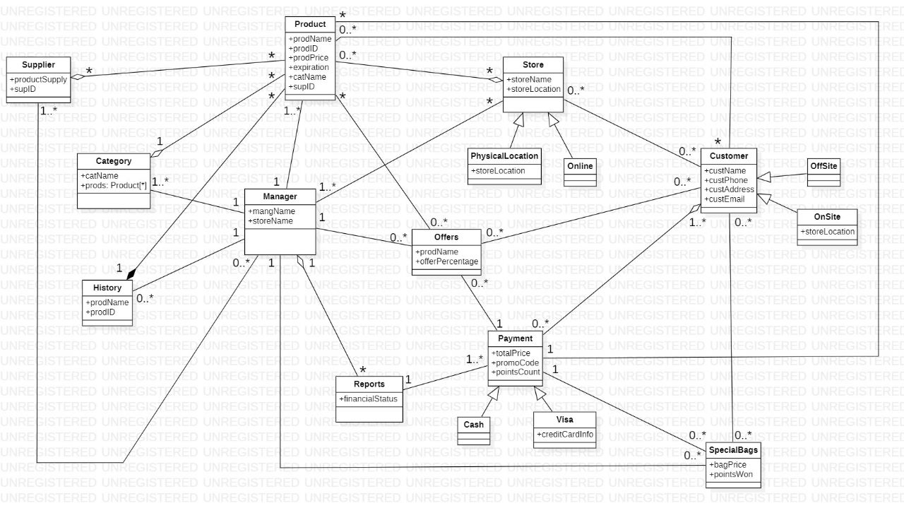**Domain Class Model**
2. **State Machine Model**

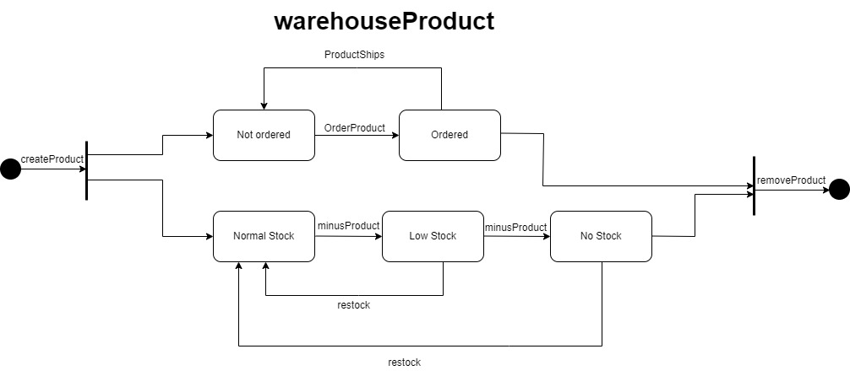

1. 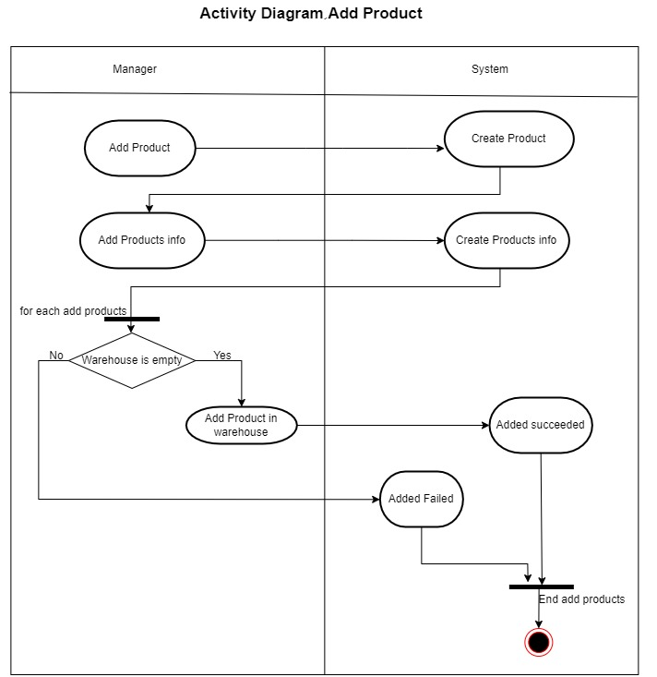**Activity Diagrams**

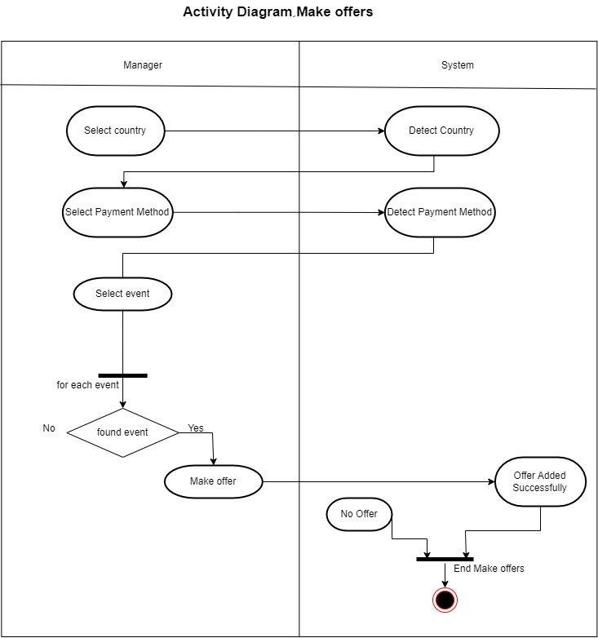

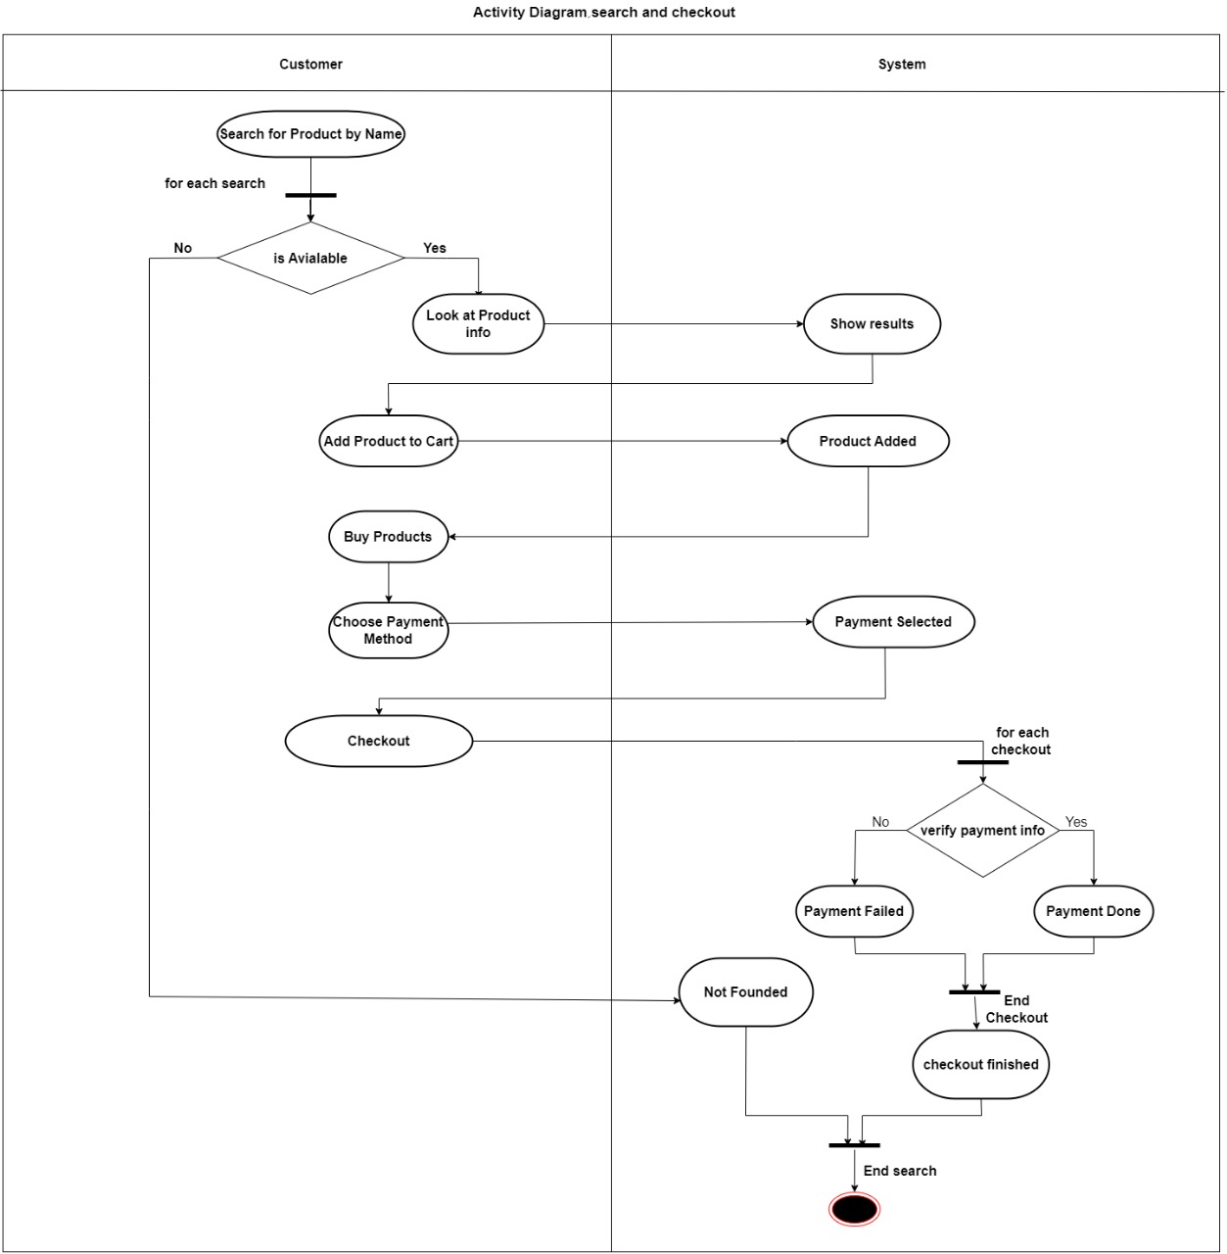

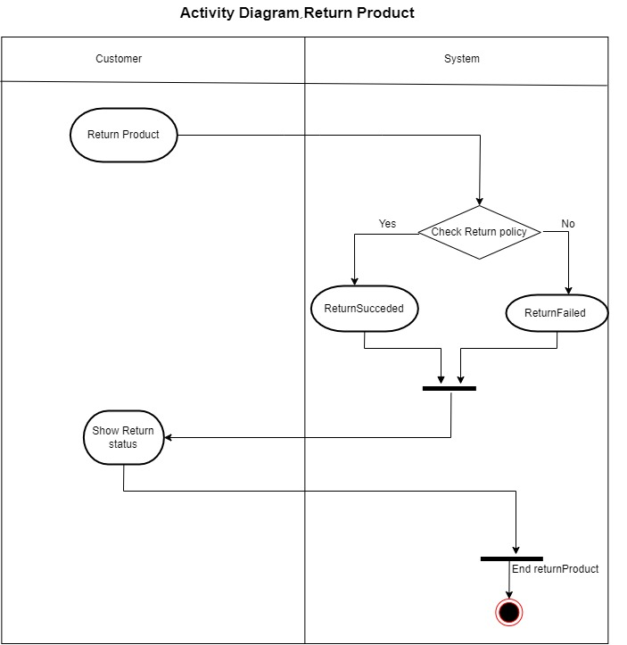

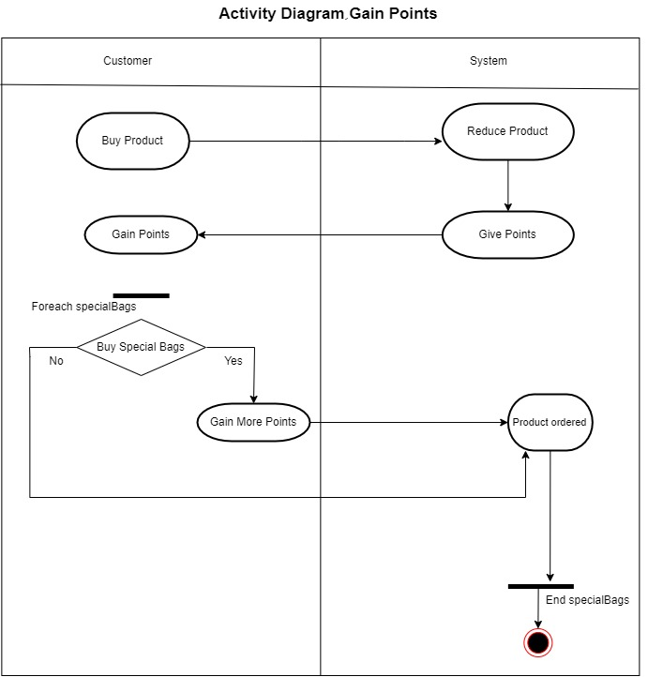

1. **System Sequence Diagrams**

